**Chinese Scientists Edit Genes of Human Embryos, Raising Concerns**

By [GINA KOLATA](http://topics.nytimes.com/top/reference/timestopics/people/k/gina_kolata/index.html)APRIL 23, 2015

The experiment with human embryos was dreaded, yet widely anticipated. Scientists somewhere, researchers said, were trying to edit genes with a technique that would permanently alter the DNA of every cell so that any changes would be passed on from generation to generation.

Those concerns drove leading researchers to issue urgent calls in major scientific journals last month to halt such work on human embryos, at least until it could be proved safe and until society decided if it was ethical.

Now, scientists in China [report](http://dx.doi.org/10.1007/s13238-015-0153-5) that they tried it.

The experiment failed, in precisely the ways that had been feared.

[Continue reading the main story](http://www.nytimes.com/2015/04/24/health/chinese-scientists-edit-genes-of-human-embryos-raising-concerns.html?hp&action=click&pgtype=Homepage&module=second-column-region&region=top-news&WT.nav=top-news&_r=0#story-continues-2)

**Related Coverage**

[[](http://www.nytimes.com/2015/03/20/science/biologists-call-for-halt-to-gene-editing-technique-in-humans.html)](http://www.nytimes.com/2015/03/20/science/biologists-call-for-halt-to-gene-editing-technique-in-humans.html)

**[Scientists Seek Ban on Method of Editing the Human GenomeMARCH 19, 2015](http://www.nytimes.com/2015/03/20/science/biologists-call-for-halt-to-gene-editing-technique-in-humans.html)**

The Chinese researchers did not plan to produce a baby — they used defective human embryos — but did hope to end up with an embryo with a precisely altered gene in every cell but no other inadvertent DNA damage. None of the 85 human embryos they injected fulfilled those criteria. In almost every case, either the embryo died or the gene was not altered. Even the four embryos in which the targeted gene was edited had problems. Some of the embryo cells overrode the editing, resulting in embryos that were genetic mosaics. And speckled over their DNA was a sort of collateral damage – DNA mutations caused by the editing attempt.

Photo

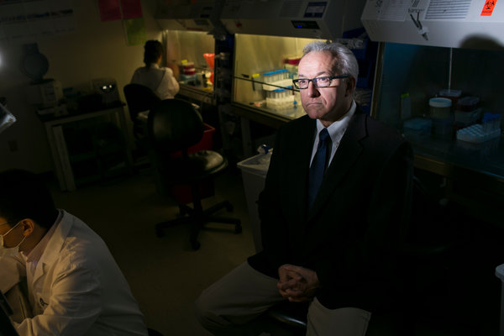

Dr. George Q. Daley has argued that current DNA editing science is not ready to be put into practice. Credit Dominick Reuter for The New York Times

“Their study should give pause to any practitioner who thinks the technology is ready for testing to eradicate disease genes during I.V.F.,” said Dr. George Q. Daley, a [stem cell](http://topics.nytimes.com/top/news/health/diseasesconditionsandhealthtopics/stemcells/index.html?inline=nyt-classifier) researcher at Harvard, referring to in vitro fertilization. “This is an unsafe procedure and should not be practiced at this time, and perhaps never.”

David Baltimore, a Nobel laureate molecular biologist and former president of the California Institute of Technology, said, “It shows how immature the science is,” adding, “We have learned a lot from their attempts, mainly about what can go wrong.”

But some researchers worry that this paper is just an initial sally and that attempts will continue with clinical applications in mind. They fear the result will be the birth of babies whose every cell has been altered by scientists in a rush to be first. This could happen well before researchers know enough about the consequences of editing genes, before they know how to edit safely and before society can debate if such procedures are even acceptable.

Gene editing uses a method called Crispr that has rapidly become a research stalwart. It exploits a system that bacteria use to protect themselves from viruses and allows researchers to cut out selected genes and insert new ones.

A pressing question, said Rudolf Jaenisch, an M.I.T. biology professor, is why anyone would want to edit the genes of human embryos in order to prevent disease. Even in the most severe cases, involving diseases like Huntington’s in which a single copy of a mutated gene inherited from either parent is enough to cause the disease with 100 percent certainty, editing poses ethical problems. Because of the way genes are distributed in embryos, when one parent has the gene, only half of the parent’s embryos will inherit it. With gene editing, the cutting and pasting has to start immediately, in a fertilized egg, before it is possible to know if an embryo has the Huntington’s gene. That means half the embryos that were edited would have been normal — their DNA would have been forever altered for no reason. “It is unacceptable to mutate normal embryos,” Dr. Jaenisch said. “For me, that means there is no application.”

Advertisement

[Continue reading the main story](http://www.nytimes.com/2015/04/24/health/chinese-scientists-edit-genes-of-human-embryos-raising-concerns.html?hp&action=click&pgtype=Homepage&module=second-column-region&region=top-news&WT.nav=top-news&_r=0#story-continues-4) [Continue reading the main story](http://www.nytimes.com/2015/04/24/health/chinese-scientists-edit-genes-of-human-embryos-raising-concerns.html?hp&action=click&pgtype=Homepage&module=second-column-region&region=top-news&WT.nav=top-news&_r=0#story-continues-4)

[Continue reading the main story](http://www.nytimes.com/2015/04/24/health/chinese-scientists-edit-genes-of-human-embryos-raising-concerns.html?hp&action=click&pgtype=Homepage&module=second-column-region&region=top-news&WT.nav=top-news&_r=0#story-continues-4)

Noting the many unresolved questions about gene editing of human embryos, a group of leading American researchers recently published a [paper](http://www.sciencemag.org/content/348/6230/36) in the journal Science calling for a moratorium on doing such work for clinical purposes. They pointed out that current knowledge about genes and their interactions is limited and that changing a disease gene in an embryo that then develops into a baby could have unintended consequences that would be inherited by all of that person’s progeny.

A recent [paper](http://www.nature.com/news/don-t-edit-the-human-germ-line-1.17111) in the journal Nature made similar points. In it, Edward Lanphier of Sangamo Biosciences in Richmond, Calif., and his colleagues wrote: “In our view, genome editing in human embryos using current technologies could have unpredictable effects on future generations. This makes it dangerous and ethically unacceptable.”

In an interview, Dr. Lanphier added, “It literally boils down to, How do you feel about the human race and the human species?”

The new paper, he said, is “a bull’s-eye example of the two issues we were concerned about.” It shows that the technology is not ready for editing genes of human embryos, he said. But, he added: “As that work goes on, if one, five, 12, 100 labs are doing it, the process could get effective. That is what we want to slow down until we have an opportunity to discuss whether it should be done.”

In their new paper, published in the online journal Protein & Cell, Junjiu Huang and Canquan Zhou and colleagues at Sun Yat-sen University in Guangzhou say they obtained human embryos from a fertility clinic. None could have developed normally because they had extra chromosomes, so they had been donated for research. The investigators used the Crispr method to try to edit a gene that, when mutated, causes beta [thalassemia](http://health.nytimes.com/health/guides/disease/thalassemia/overview.html?inline=nyt-classifier), a serious blood disorder. Their goal was to alter that gene and only that gene in every cell of the developing embryo.

The Chinese researchers point out that in their experiment gene editing almost certainly caused more extensive damage than they documented; they did not examine the entire genomes of the embryo cells.

Dr. Daley notes that when cloning techniques were developed, there was an international consensus that it would be unacceptable to clone a human being. Nonetheless, some researchers tried. He worries that something similar will happen with gene editing.

“This type of intervention would achieve worldwide acclaim,” Dr. Daley said. “I think that is the sort of deranged motivation that sometimes prompts people to do things.”